MASSACHUSETTS BAY TRANSPORTATION AUTHORITY
PROJECT MANAGER’S MANUAL
STANDARD OPERATING PROCEDURE
SECTION 2 - PROJECT PLANNING (BUDGET) |  | NUMBER: Rev. 4
REVISION DATE:
01/27/14

  - PROJECT PLANNING (BUDGET)

  - Capital Investment Program (CIP)

The CIP is a 5-year program of improvements that provides primary scope, schedule, and budget direction to the MBTA and the MBTA Design and Construction program. It must be annually updated and approved by the MBTA Board of Directors. Thus, the period covered by the CIP includes the current budget year and the four years that follow.

The CIP document presents basic project information, including:

- Project title, category, and a brief description of its scope
- Impacts on the Environment, State of Good Repair, and Operations
- Legal Requirements
- Impact on Operating Budget
- Conceptual Budget and Schedule
- Total Capital Spending by Fiscal Year
- Funding sources

    - Capital Funding Requests and CIP Approval

When a sponsor department identifies a need for a capital project, a representative of the sponsor department writes a concise capital funding request (CFR). The CFR is located at the end of this section. Based on the criteria described below, the CFR is submitted to the Assistant General Manager (AGM) of Design and Construction and a Project Manager is assigned.

For capital project development, long range projects and feasibility studies, the Director of Planning requests the Assistant General Manager of Design & Construction to assign a Project Manager.

Upon assignment, the Project Manager completes the Project CFR, including a Conceptual Budget and Schedule. The AGM for Design and Construction submits CFRs to the Deputy Director of Capital Budget on an annual basis. Guided by the selection criteria set primarily by Forward Funding legislation, the Budget Department ranks the Capital Funding Requests and works in conjunction with top senior management to determine which CFRs will ultimately be incorporated into the Five Year CIP. The Board of Directors approves the CIP in its entirety.

    - Project Implementation

The implementation of individual projects is subject to funding availability and the required authorization level. Once the CIP is approved, the Budget Department works to initiate individual projects by identifying the necessary funding. It is the goal of the MBTA to use Federal funds for as many projects as possible. Therefore, all projects must follow federal procurement guidelines. Although the project may be listed within the CIP, it may not move forward until funding is adequately identified (i.e. Federal, State or other). It is recommended that the Project Manager contact the Manager of Federal Programs or the Deputy Director of Capital Budget within the Budget Office for further guidance. Funding may take upwards of 3-6 months, depending on the source of those funds. Project Managers should work closely with the Manager of Federal Programs in the Budget Department to provide the background information for the filing of federal grant applications.

Once a project has been initiated by the Budget Department, the project must receive authorization from the Board of Directors, Secretary of Transportation, GM, AGM, or Director, depending on the size of the project’s budget. Please refer to Section 3 for MBTA authorization levels when seeking to implement projects.

  - Infrastructure Reinvestment Projects/Construction

Infrastructure Reinvestment projects for which Design and Construction takes the lead role include bridges and tunnels, transit facilities, commuter rail, other facilities and Transit Oriented development, and general design and architectural projects. The construction of system expansions and enhancements are also managed by Design and Construction.

  - Pre-Design Activities

Once the CIP identifies a project as having the required priority status and available funding, the pre-design phase is initiated. The intent of pre-design is to evaluate the proposed project for conformity with long-range comprehensive planning, potential assessments, and coordination with other proposed projects.

The Sponsor Department for projects managed by Design and Construction must submit a CFR identifying the problem/need and the proposed scope of work (see Exhibit 2.1.0). The CFR requires approval by a Director from the Sponsor Department (or equivalent position). After receiving such approval, the Director submits the CFR to the AGM for Design and Construction.

The CFR form is located in an Access database called the CFR Database. However, a blank Word version of the CFR form can be distributed for editing before the final submittal is done through the CFR Database. Note that only pre-selected individuals will have access to the shared network drive (the “Q” drive) on which the CFR Database is located. To request access for an individual, contact Capital Budget.

  - Selection of Project Manager

After receiving the CFR, the AGM for Design and Construction reviews the summary and determines if it is complete. If it is deemed complete, the Assistant General Manager assigns a Project Manager to the proposed Project. If the CFR is incomplete, it is returned to the Sponsor Department for completion and resubmission.

  - Submission of Capital Funding Request

After the Project Manager is selected, his or her first priority is to review the Capital Funding Request, which includes the Conceptual Budget and Schedule and Projections by Fiscal Year. The Project Manager should work with the Sponsor Department as necessary to complete the Capital Funding Request.

Upon approval by the AGM for Design and Construction, CFRs are submitted on an annual basis to Capital Budget via the CFR Database, except where urgent circumstances dictate quicker submission.

  - Capital Funding Request Prioritization Process

Capital Budget performs a prioritization of the CFRs based on the following considerations:

Prioritization of projects to be included in the CIP is based on the following criteria, as defined by MBTA senior management and reflected in the MBTA’s enabling legislation: the impact of the project on the effectiveness of the Commonwealth’s transportation system, service quality, the environment, health, the state of good repair of MBTA infrastructure, and the Authority’s operating costs and debt service. Projects that receive the highest priority are those with the greatest benefit and the least cost, as prioritized by the following criteria:

- Factor One: Impact on the Environment / Alignment with GreenDOT Objectives. Two criteria are used to assess the impact of the project on the environment including areas of focus as identified in the GreenDOT objectives:

  - Pollution Reduction and Consumption of Natural Resources. This criterion assesses if and how the project reduces pollution (greenhouse gas or other air pollutant emissions, water pollutants, trash) or the consumption of natural resources (energy and water) through the use of technology, improved procedures, or other measures.
  - Promote Mode Shift. This criterion assesses if and how the project encourages a shift in the mode of transportation utilized by travelers away from private vehicles and to the healthy transportation options (walking, biking, and public transit) identified in the GreenDOT objectives.

- Factor Two: System Preservation. These criteria are used to assess the impact of the project on system preservation:

  - State of Good Repair (SGR) Database Rating. The CFR submittal includes a list of assets affected by the project that can be referenced in the SGR Database. This criterion provides the average SGR rating (a measurement of an asset’s state of repair) for these assets from the SGR Database.
  - Lifecycle Management. This criterion assesses if the following elements are or will be associated with the project’s assets: an inventory of the assets, up-to-date condition assessments, a preventative maintenance plan (including documented schedules and organizational responsibilities), and documented maintenance and inspection training procedures for staff.
  - Reduce Vulnerability to Climate Change / Extreme Storms. This criterion assesses if and how the project will reduce vulnerability to floods, storms, landslides, and drastic temperatures through the use of technology, improved procedures, or other measures.

- Factor Three: Impact on the Operating Budget. These criteria are used to assess the impact of the project on the operating budget:

  - Impact on Operating Costs. This criterion assesses how the project would impact the Authority’s operating costs – in terms of labor, materials, utilities, etc.
  - Impact on Operating Revenues. This criterion assesses how the project would impact the Authority’s operating revenue – in terms of fares, advertising, real estate, etc.

- Factor Four: Impact on Operations. These criteria are used to assess the impact of the project on operations:

  - Impact on Customer Experience. This criterion assesses how the project would impact customer satisfaction and the customer experience through service quality improvements, accessibility improvements, providing new services, or other measures.
  - Operations Criticality. This criterion assesses the extent to which the project affects assets that are critical to the Authority’s daily operations.
  - Operational Sustainability. This criterion assesses the extent to which the operational impact/benefits of the project are sustainable in future years by considering whether the Authority has the resources (sufficient skills, dedicated personnel and time, and the availability of funding) to sustain the assets associated with the project.

The MBTA also considers the implications of several other factors in its capital investment decision-making process. These include any legal requirements addressed by the project, the consequences of not funding the project, each MBTA department’s own internal ranking of projects, and environmental justice implications. With regard to analyzing environmental justice, the MBTA has worked with the Central Transportation Planning Staff (CTPS) and the Boston Metropolitan Planning Organization (MPO) to ensure that minority and low-income regions are treated equitably regarding the delivery of transportation services.

  - Budget and Schedule

Senior managers throughout the MBTA, Board members, the Project Development Group and other interested parties all require a basic understanding of Project cost at the outset of the Project, however, little or no engineering has been performed, environmental concerns are not fully understood, little community outreach has been undertaken, etc. For these reasons, project scope and cost can be estimated only with a margin of error. This section addresses the MBTA’s need to present cost and schedule data at Project outset while recognizing that such estimates are preliminary.

During design of the projects by the time 30% design has been attained, much more is known about Project requirements and a more precise estimate and schedule can be developed. By 60% design, most projects should require only a relatively modest contingency to account for field conditions and other unforeseen circumstances. This manual sets forth MBTA policy with respect to what is required of a 30% estimate and schedule, including force account budgets and actions at the 30% level. It also holds Project Managers accountable to budgets and schedules developed at the 30% design stage.

The Project Manager recommends a Conceptual Budget and Schedule when preparing the Capital Funding Request at Project Initiation.

The Conceptual Budget and Schedule includes adequate contingencies for unknowns in the design and construction phases of the Project. Conceptual Budgets and Schedules are part of the Capital Funding Requests submitted to the Budget Director and when approved are included in the Five Year Capital Investment Program (CIP). The Conceptual Budget is used as a basis to proceed with the project until a 30% design estimate is established and a more final version of the Budget is prepared.

Once the Project achieves the 30% design milestone, the Project Manager will prepare a more finalized budget and schedule. This Budget includes reduced contingencies, reflecting a greater degree of certainty about what is being built. For non-construction projects (e.g. fleet procurement), the budget and schedule is submitted to Capital Budget when project specifications or scope are essentially developed. Changes to the Conceptual Budget and Schedule that require increased funding are transmitted via a Capital Funding Request by the AGM for Design and Construction to Capital Budget for inclusion in the 5-Year Capital Investment Program. Project Managers are responsible for completing their Projects within the approved budget and schedule.

Conceptual Budget and Schedule

No Capital Project may be included in the Five-Year Plan until the Project Manager has prepared a Capital Funding Request, including a Conceptual Budget and Schedule, which must be approved by the applicable Director, the Chief Engineer, and the AGM. The Project Manager develops the Conceptual Budget and Schedule with the assistance of the Sponsor and other Departments, using the following guidelines. It is essential that, as in the development of every cost and schedule estimate, the PM must develop and include a Basis and Assumptions document that outlines the assumptions being used.

Conceptual Budget Summary

These line items are estimated:

Task Budgets: cost estimates for each task (backup documentation should be attached) required to complete the Project, including:
- Design and Engineering: estimated total costs of environmental assessment, Conceptual (0-15%), Preliminary (15-30%), Development 30-60% and Final (60-100%) design, including any special engineering studies, construction document preparation, technical bid review, and construction phase services, exclusive of escalation. If anticipated, also include PM/CM costs.
- Construction Contracts: estimated bid cost of the Project’s construction contract and/or in-house construction, exclusive of escalation but including allowances for mitigation, site cleanup, traffic control, and all subcontracts. A more detailed breakdown of individual contracts and/or costs under this line item should be attached.

- Construction Contingency: Depending on the type of project and the risk associated with it, a percentage of the preceding estimate to account for potential change orders, claims, etc. Contingency is to be carried as a separate line item. The PM should work with the Project Controls Group to develop an appropriate contingency amount. See Section 5 for guidance.)
- Vehicles and Capital Equipment: estimated cost of capital, non-construction items to be purchased (e.g., vehicles, signal equipment, and computers).
- Vehicles and Capital Equipment Contingency: 5% of the preceding estimate to account for potential change orders. Contingency is to be carried as a separate line item.
- Land Acquisition: estimated cost of any temporary or permanent easements, takings, negotiated settlement, or other acquisition required to construct the Project, including the cost of appraisals, review appraisals, title opinion services, relocation consultant services, relocation claim payments, outside legal counsel services and land damage judgments. These estimates must be reviewed with the Real Estate Acquisition Staff.
- Soft Costs: itemized, estimated total in-house (labor) costs associated with project development, exclusive of the costs of in-house engineering, design and construction. Itemized soft costs include, but are not limited to:
    - Inspection (include fringe rate)

    - Flagging/Force Account (include fringe rate)

    - Project Administration (include fringe rate)

    - Indirect costs

    - Insurance, as needed

At the conceptual budget stage, soft costs generally total 30%-50% of Construction costs. The PM shall coordinate with the Administration & Finance Department to establish the soft costs.

- Escalation: Based on the Conceptual Schedule, all Design phase costs (i.e. all costs expected to be incurred prior to the Bid Date) are escalated to the mid-point of design, and all Construction phase costs (all costs expected to be incurred on or after the Bid Date) to the mid-point of construction.
- Project Subtotal: The total of the preceding items.
- Project Contingency: Depending upon the nature/complexity of the Project a project contingency should be calculated in accordance with the MBTA Project Controls Manual. The Project Contingency is taken to reflect uncertainties regarding environmental conditions, community review, site conditions, materials and means of construction, etc. The Project Contingency is reduced over the span of Project development, until, by the completion of the project,, it has been reduced to 0%.
- Conceptual Budget Cash Flows: Conceptual Budget submissions should be accompanied by an estimate of annual spending, by fiscal year.
- Conceptual Schedule: The Project Manager estimates the completion dates of Key Milestones and identifies critical path issues and other assumptions that will potentially affect the schedule or budget. These milestones are estimated:
    - Completion of Conceptual Design
    - Any procurement of PS services
    - Completion of Environmental Assessment
    - Completion of Preliminary (30%) Design Review
    - Identification of Authorized Budget and Schedule
    - Completion of 60% and 90% Design Reviews
    - Completion of Final Design and Permitting (not to exceed five (5) years from date of award)
    - Advertisement Date
    - Contract Award and Construction NTP
    - Construction/Delivery Milestones
    - Substantial Completion
    - Completion of Closeout

Approval of Conceptual Budget and Schedule
The Project Manager reviews the draft Conceptual Budget and Schedule with the appropriate Director, Chief Engineer, and AGM and transmits it to the AGM for Design and Construction, the Chief Operating Officer, or the Director of Planning, as appropriate. The appropriate senior manager then transmits it to the Budget Director as part of the Capital Funding Request.
    - Updating the Conceptual Budget and Schedule

Once the Project reaches the 15% design milestone, the Project Manager shall update the Conceptual Budget and Schedule, based on consideration of a minimum of three design alternatives (if applicable).

    - 30% Budget Update

At the 30% design milestone the project should be more defined and the Budget updated to reflect the changes. The PM shall follow the guidance outlined in the Project Controls Manual. At this stage, any update shall include an explanation of any variance from the approved budget.

- Task Budgets: cost estimates for each task (backup documentation should be attached) required to complete the Project, including:

- Design and Engineering: actual total costs of environmental assessment, Conceptual Design (0-15%) and Preliminary Design (15-30%) and estimated (or actual if available) costs of 30% - 100% design, including any special engineering studies, construction document preparation, technical bid review, and construction phase services.
- Construction Contracts: estimated bid cost of the Project’s construction contract and/or in-house construction, including all subcontracts, exclusive of escalation, but including allowances for mitigation, site cleanup, and traffic control. A more detailed breakdown of individual contracts and/or costs under this line item should be attached.
- Construction Contingency: Project Managers should coordinate with MBTA Project Controls to determine an appropriate contingency percentage that is based on the risk for a project’s particular classification. The contingency is to account for change orders, claims etc. Contingency is to be carried as a separate line item.
- Vehicles and Capital Equipment: estimated cost of capital, non-construction items to be purchased (e.g., vehicles, signal equipment, and computers).
- Vehicles and Capital Contingency: 5% of the preceding estimate to account for potential change orders. Contingency is to be carried as a separate line item. Land Acquisition: estimated (or actual if available) cost of any temporary or permanent easements, takings, or other acquisition required to construct the Project. As described in the later section on Real Estate Acquisition, projects cannot proceed past the 30% design milestone until there is an estimate completed by Real Estate Acquisition staff for land acquisition. This estimate is incorporated into the Budget.
- Soft Costs: itemized, estimated total in-house (labor) costs associated with Project development, exclusive of the costs of in-house engineering, design and construction. Itemized Soft Costs include, but are not limited to:
    - Inspection (with fringe rate)
    - Flagging/Force Account (with fringe rate)
    - Project Administration (with fringe rate)
    - Indirect Costs
    - Insurance, as needed
At the 30% update, Soft Costs are estimated based on the specific requirements of the Project and approved by the heads of the relevant MBTA departments.
    - Escalation: Design phase costs are presented in year-of-expenditure dollars. Based on the Authorized Schedule, construction phase costs are escalated to the mid-point of construction.

    - Project Subtotal: The total of the preceding items.

    - Project Contingency: Depending upon the nature and complexity of the project a project contingency of 5%-10% of the project subtotal should be calculated. The project contingency is taken to reflect ongoing but significantly reduced uncertainties regarding environmental conditions, community review requirements, site conditions, materials and means of construction, etc. If at the completion of 60% design, a project contingency in excess of 5% of the project subtotal remains (i.e., has not been allocated to task budgets), the Chief Financial Officer may reallocate any such funds in excess of 5% of the project subtotal to other projects.

    - Budget Cash Flows: The updated budget accompanied by an estimate of annual spending by fiscal year.

    - Schedule: At this stage of project development, the Project Manager reevaluates the Key Milestones developed at the Conceptual Budget stage and presents these to the Project Development Group (PDG) at the 30% meeting. The PM shall include in the presentation to the PDG a more detailed, expanded set of Project milestones and critical path issues for consideration.

  - Managing the Budget

The Project Manager is responsible for managing the project to the budget and schedule. The Project Manager will complete a monthly review of the Budget to compare forecast and actual expenditures, schedules with the established Schedule, to document the use of contingency, and to make required adjustments to budget allocations. In the case of variances, the Project Manager will develop an action plan to reduce total cost or revise the schedule as appropriate. The updated Budgets will be reviewed with the Budget Analyst to assure adequate funding is available for all items. This shall be documented in the monthly AGM report.

    - Budget Revisions

If a budget revision is necessary, the PM shall prepare a memorandum outlining the required revisions. The PM shall consult with the Budget Analyst when preparing Exhibit 2.1.3. Exhibit 2.1.3 shall be concurred by the Director of Administration and Finance. A breakdown of the budget revision shall be prepared by Administration and Finance and included with the Budget Revision Memo as an attachment. The Budget Revision Memo will be submitted to the Budget Department to ensure that appropriate changes are made within the Capital Management System (CMS).

    - Use of Project Contingencies to Fund Budget Shortfalls

Prior to the completion of 60% design, use of the project contingency to fund shortfalls in the Task Budgets requires the following levels of approval, based on percentages of the Budget Project Subtotal:

REQUIRED APPROVAL – Prior to completion of 60% Design
% of Project Subtotal | Individual Change | Cumulative Change
<2% and <$200,000 | Project Manager | Project Manager
2% -4% and <$500,000 | AGM for Design & Const., Chief Operating Officer, or Director of Planning, as applicable | AGM for Design & Const., Chief Operating Officer, or Director of Planning, as applicable
> 5% or <$1,000,000 | GM | GM

Between 60% and 100% design, use of the Project Contingency to fund shortfalls in the Task Budgets requires the following levels of approval, based on percentages of the Project Subtotal.

REQUIRED APPROVAL – Beyond completion of 60% Design
% of Project Subtotal | Individual Change | Cumulative Change
<1% and <$100,000 | Project Manager | Project Manager
1 % - 2% and <$200,000 | Director of Construction, Chief Operating Officer or Director of Planning | Project Manager
2% - 4% and <$500,000 | AGM for Design & Constr., Chief Operating Officer, or Director of Planning | AGM for Design & Constr., Chief Operating Officer, or Director of Planning
>5% or <$1,000,000 | GM | GM

Following the bid process and prior to contract award, the senior manager of the Department reviews and approves any changes to the budget necessary to fully fund the Construction Contract and Contingency.

Any changes to the Budget that result from Change Orders must be approved in the manner specified in the Change Order Guidelines defined later in this PM Manual. It is important that Project Managers understand the difference between the authorization processes for an entire project versus amendments or changes to a project. The entire project is authorized after the CIP to which it belongs is approved by the Board of Directors and the Budget Department has identified funding for the project (see Section 2.1.3). Amendments or changes to a project are authorized by the Board of Directors, Secretary of Transportation, GM, AGM, Chief Engineer, or Director, depending on the size of the project’s budget. Please refer to Section 3 for MBTA authorization levels when seeking approval for specific contract actions such as amendments and change orders.

Amendment of the Schedule

The Project Manager approves changes to the schedule, but any changes that affect the dates and/or that affect the budget requires the approval of the Director, Chief Engineer, and AGM.

  - Amendments to the Budget

Any increase to the overall Budget requires approval of the Budget Director, who must identify the monies required to fund such a shortfall. Amendments to the Budget are required when budget variances are identified in the project status report and the Project Manager does not foresee any actions that could be implemented to recover these expected cost overruns. The first step in determining whether a new Capital Funding Request is needed should be for the PM to review all Budget Department reports currently prepared for ongoing projects.

When any “Cost-to-Complete” column in any Budget Department report exceeds the “Current Authorized Budget” column, a Capital Funding Request may be initiated.

A narrative should be attached to the Amendment providing an explanation for each line item with a projected budget variance. The Project Manager should identify potential alternatives or actions that could be performed to help contain or recover these costs. The Project Manager shall exhaust all other remedies for budget overruns before requesting an amendment to the approved Budget. The Project Manager shall consult with the Budget Analyst for the project to assure that other remedies are not available. If the approved budget must be amended due to project conditions the Project Manager shall prepare and process a Capital Funding Request detailing the requested changes.

  - Reporting

    - Quarterly Milestone Reporting
The MBTA is required to submit quarterly Milestone/Progress Reports (MPR’s) to the Federal Transit Administration (FTA). Reports are due 30 days after the end of each federal fiscal quarter (federal fiscal year begins on October 1st). MPR’s are processed by the budget department electronically, using the FTA’s Transportation Electronic Award & Management (TEAM-Web) software. In order to allow adequate time for processing, project managers are required to submit quarterly reports to the budget department a week in advance of the reporting deadline. The Assistant Manager of Federal Programs will send out an e-mail reminder requesting Quarterly Reports to Directors 2 weeks in advance of the end of quarter. Reports are completed using a template (attached) provided by the Budget Department to facilitate ease of data entry into TEAM.

The FTA details the information that, at a minimum, must be included in these reports in its regulations:

- Current status of each open Activity Line Item (ALI) within the active/executed grant.
- A narrative description of projects, status problems encountered in implementation, specification preparation, bid solicitation, resolution of protests, and contract awards.
- Detailed discussion of all budget or schedule changes.
- The dates of expected or actual requests for bid, delivery, etc.
- Actual completion dates of completed milestones.
- Revised estimated completion dates when original estimated completion dates are not met accompanied by:
  - Explanation of why scheduled milestones or completion dates were not met.
  - Identification of problem areas.
  - Narrative on how the problems will be solved.
- Discussion of the expected impacts and the efforts to recover from the delays.
- Analysis of significant project cost variances using quantitative measures, such as hours worked, sections completed, or units delivered. Discussion of completion and acceptance of equipment and construction or other work, together with a breakout of the costs incurred and those costs required to complete the project.
- A list of all outstanding claims exceeding $100,000, and all claims settled during the reporting period accompanied by a brief description, estimated costs, and the reasons for the claims.
- A list and brief description of all potential and executed change orders and amounts exceeding $100,000, pending or settled, during the reporting period.
- A list of claims or litigation involving third party contracts and potential third party contacts that:
  - Have a value exceeding $100,000.
  - Involve a controversial matter, irrespective of amount.
  - Involve a highly publicized matter, irrespective of amount.
- A list of all real property acquisition actions, including just compensation, property(s) under litigation, administrative settlements, and condemnation of each parcel during the reporting period.
- An annual transit enhancements report (4th quarter only) for designated recipients in urbanized areas who receive funds under Section 5307.

If a grant includes only operating assistance, the reporting requirement is limited to the estimated and actual date when funding has been expended.

When completing the MPR template, it is important that PM’s make certain that the Revised Estimated Completion Date and Actual Completion Date field for each milestone has been updated if applicable. Provide a narrative explanation of changes, as they occur. Large narratives should be sent via e-mail to the Assistant Manager of Federal Programs in Microsoft Word format and he/she will include the document as a file attachment to the FTA Quarterly Narrative Report.

It is critical that all grant reporting be completed accurately, in a detailed manner, and on time. The FTA has cited the MBTA in the past for lack of detail on MPR’s and may withhold funding if reports are not submitted satisfactorily.

2.11 Grant Closeout Process
Once a grant is completed, it must be closed out internally within CMS and externally (in the case of Federal grants) within TEAM. The project manager should notify the Assistant Manager of Federal Programs via email that the grant is completed. The Budget Department will verify the following:

- All funds have been distributed and expended and that the dollar amounts match up with the FTA funding amount. (Note: Remaining funds must either be expended under the scope of the grant or they will be de-obligated).
- The project is completed and all contractors have been paid.
- There are no remaining work orders open in CMS.
- The Final Milestones Report has been submitted.

Upon verification of all the above with the project manager, the Budget Department will close out the grant in CMS and in TEAM.

Massachusetts Bay Transportation Authority CFR Form (6/23/2011)
Budget Department

Exhibit 2-1
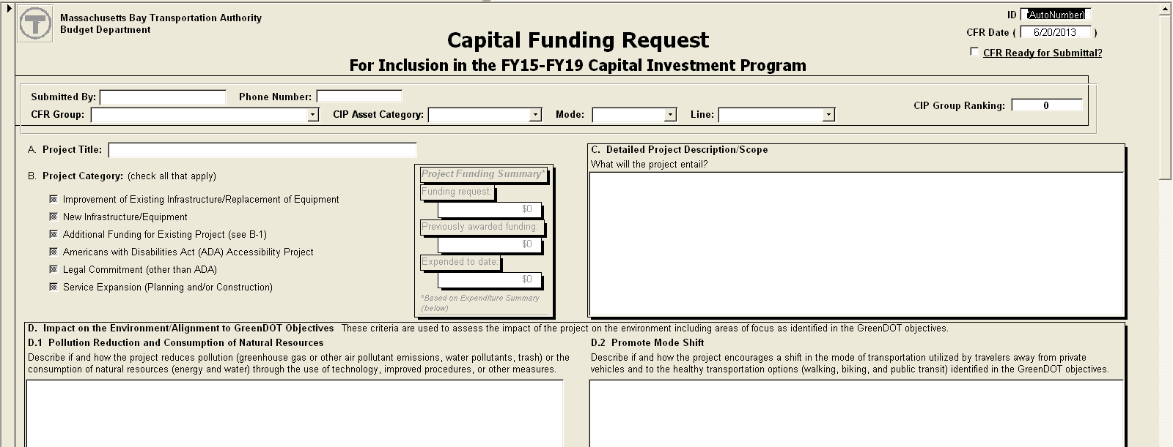
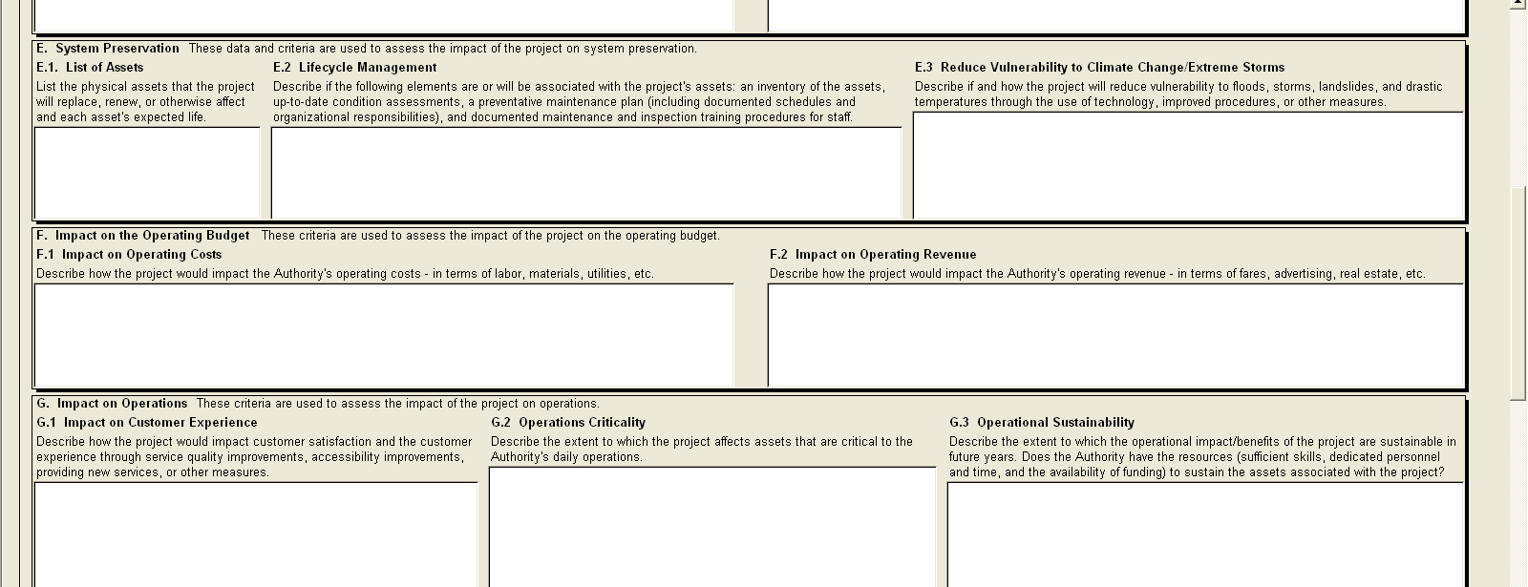
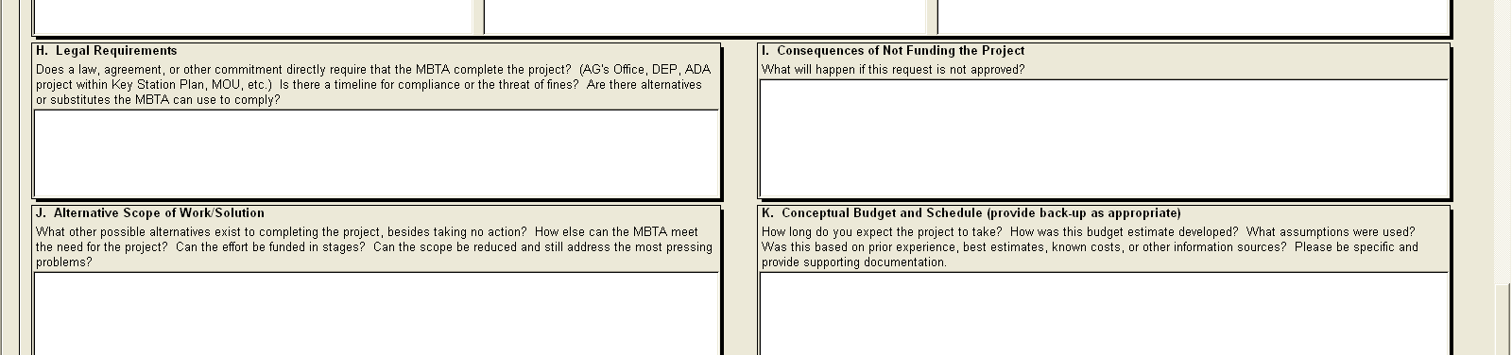
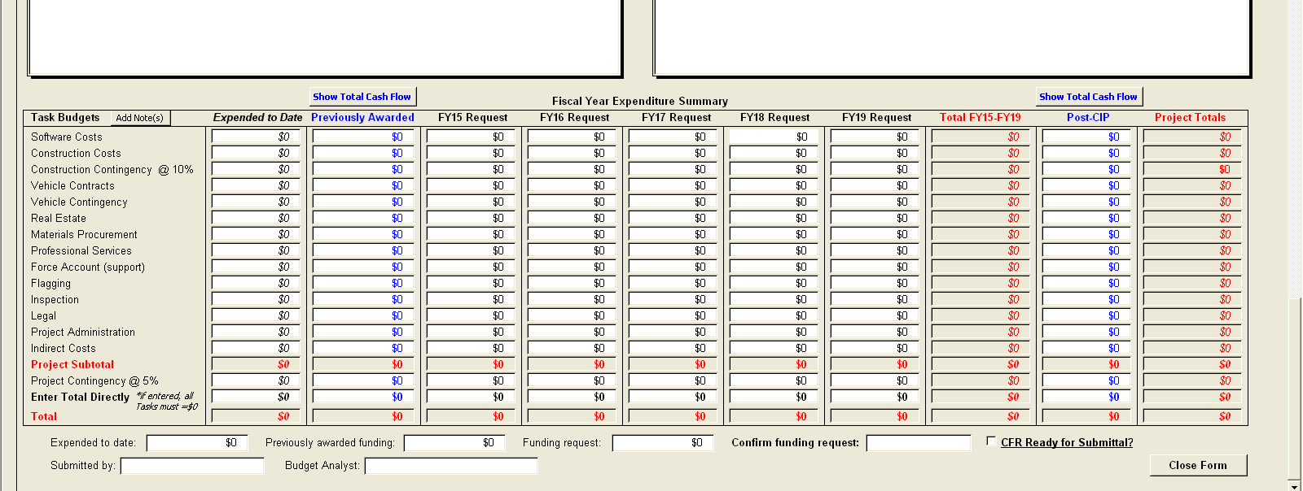

MASSACHUSETTS BAY TRANSPORTATION AUTHORITY
PROJECT MANAGEMENT MANUAL
STANDARD OPERATING PROCEDURE
SUBJECT: Project Initiation Report |  | NUMBER: PMM-SOP-2-2
 |  | REVISION DATE: Draft

A. Department Sponsor:

(Design & Construction), (Operations), (Operations Support), (Development), (Department of Transportation) etc.

B. Project Number: ____________________________
Project Name:_______________________________________________

(The number is for tracking reviews and comments on submissions. If the project originates externally to the MBTA, the number used for tracking purposes can be the number assigned by the owner or consultant on the project.)

C. Project Category: (Insert the source of the Project such as 5 Year Plan, TOD, Planning, etc.)

D. Project Description/Scope
(Brief Description of project scope)

E. MBTA Project Manager: _____________________________________
F. Department: _________________________________________

G. Support Services Required of Other Departments:

H. Budget & Schedule
(Insert Conceptual Budget & Schedule for Capital Projects or Estimated Budget &
Schedule for other projects)

- Funding Source

J. Special Instructions
Project Initiation Report (cont.)

K. Project Development Group (PDG)
(Check all that apply)

⁪Design and Construction: ⁪QA Department ⁪Design ⁪Administration & Finance (Budget Analyst) ⁪Other _________________________________________
⁪Systemwide Accessibility ⁪Engineering & Maintenance (E&M)
⁪Signal Department ⁪Communications Department ⁪Maintenance of Way
⁪Operations Support: ⁪Power Division ⁪Building Division
⁪Development ⁪Planning ⁪Environmental Affairs ⁪Bus Operations ⁪Safety Department
⁪Subway Operations:
⁪ Green Line ⁪ Orange Line ⁪ Red Line ⁪ Silver Line
⁪Railroad Operations ⁪Water Transportation ⁪Budget Department ⁪Marketing ⁪Department Intergovernmental and Public Affairs ⁪Legal Department
⁪Police Department ⁪AFC Department ⁪Parking

Approval: _________________________________________ Date: _______________
Sr. Manager of Sponsoring Department

Concur: ___________________________________________ Date: _______________
Sr. Manager of Supporting Department

PM Manual Exhibit 2-1 (word version)
2014-01-27

Massachusetts Bay Transportation Authority Budget Department

Capital Funding Request
For Inclusion in the FY15-FY19 Capital Investment Program
CFR Group: CIP Asset Category:
Mode: Line: Rank:
Submitted By: Phone #:
A. Project Title:
B. Project Category (check all that apply – double click box to check):
Improvement of Existing Infrastructure/Replacement of Equipment
New Infrastructure/Equipment
Additional Funding for Existing Project (see B-1)
Americans with Disabilities Act (ADA) Accessibility Project
Legal Commitment (other than ADA)
Service Expansion (Planning and/or Construction)
C. Detailed project description/scope. What will this project entail?

D. Impact on the Environment/Alignment to GreenDOT Objectives
These criteria are used to assess the impact of the project on the environment including areas of
focus as identified in the GreenDOT objectives.
D.1. Pollution Reduction and Consumption of Natural Resources
Describe if and how the project reduces pollution (greenhouse gas or other air pollutant
emissions, water pollutants, trash) or the consumption of natural resources (energy and water)
through the use of technology, improved procedures, or other measures.

D.2. Promote Mode Shift
Describe if and how the project encourages a shift in the mode of transportation utilized by
travelers away from private vehicles and to the healthy transportation options (walking, biking, and
public transit) identified in the GreenDOT objectives.

E. System Preservation
These data and criteria are used to assess the impact of the project on system preservation.
E.1. List of Assets
List the physical assets that the project will replace, renew, or otherwise affect and each asset's
expected life.

E.2. Lifecycle Management
Describe if the following elements are or will be associated with the project's assets: an inventory
of the assets, up-to-date condition assessments, a preventative maintenance plan (including
documented schedules and organizational responsibilities), and documented maintenance and
inspection training procedures for staff.

E.3. Reduce Vulnerability to Climate Change/Extreme Storms
Describe if and how the project will reduce vulnerability to floods, storms, landslides, and drastic
temperatures through the use of technology, improved procedures, or other measures.

F. Impact on the Operating Budget
These criteria are used to assess the impact of the project on the operating budget.
F.1. Impact on Operating Costs
Describe how the project would impact the Authority's operating costs - in terms of labor,
materials, utilities, etc.

F.2. Impact on Operating Revenue
Describe how the project would impact the Authority's operating revenue - in terms of fares,
advertising, real estate, etc.

G. Impact on Operations
These criteria are used to assess the impact of the project on operations.
G.1. Impact on Customer Experience
Describe how the project would impact customer satisfaction and the customer experience through
service quality improvements, accessibility improvements, providing new services, or other
measures.

G.2. Operations Criticality
Describe the extent to which the project affects assets that are critical to the Authority's daily
operations.

G.3. Operational Sustainbility
Describe the extent to which the operational impact/benefits of the project are sustainable in future
years. Does the Authority have the resources (sufficient skills, dedicated personnel and time, and
the availability of funding) to sustain the assets associated with the project?

H. Legal Requirements
Does a law, agreement, or other commitment directly require that the MBTA complete the project?
(AG's Office, DEP, ADA project within Key Station Plan, MOU, etc.) Is there a timeline for
compliance or the threat of fines? Are there alternatives or substitutes the MBTA can use to
comply?

I. Consequences of Not Funding the Project
What will happen if this request is not approved?

J. Alternative Scope of Work/Solution
What other possible alternatives exist to completing the project, besides taking no action? How
else can the MBTA meet the need for the project? Can the effort be funded in stages? Can the
scope be reduced and still address the most pressing problems?

K. Conceptual Budget and Schedule (provide back-up as appropriate)
How long do you expect the project to take? How was this budget estimate developed? What
assumptions were used? Was this based on prior experience, best estimates, known costs, or
other information sources? Please be specific and provide supporting documentation.

Expenditure Summary
Submitted By:
Budget Analyst:
Grant ID (for previously awarded funding - if applicable):
Project Title:
Sponsor Dept.:
Expended Previously CIP
Task Budgets to Date Awarded FY15-FY19 Post-CIP Project Total
Software
Construction
Const. Contingency
Veh. Contracts
Veh. Contingency
Real Estate
Materials
Prof. Services
Force Acct.
Flagging
Field Inspection
Legal
Proj. Admin.
Indirect Costs
Proj. Subtotal
Proj. Contingency
Direct Enter Tot.
Total
Task Budgets FY15 FY16 FY17 FY18 FY19
Software
Construction
Const. Contingency
Veh. Contracts
Veh. Contingency
Real Estate
Materials
Prof. Services
Force Acct.
Flagging
Field Inspection
Legal
Proj. Admin.
Indirect Costs
Proj. Subtotal
Proj. Contingency
Direct Enter Tot.
Total
Task Notes
Software Costs:
Construction Costs:
Construction Contingency:
Vehicle Contracts:
Vehicle Contingency:
Real Estate:
Materials Procurement:
Professional Services:
Force Account (support):
Flagging:
Field Inspection:
Legal:
Project Administration:
Indirect Costs:
Project Contingency:

