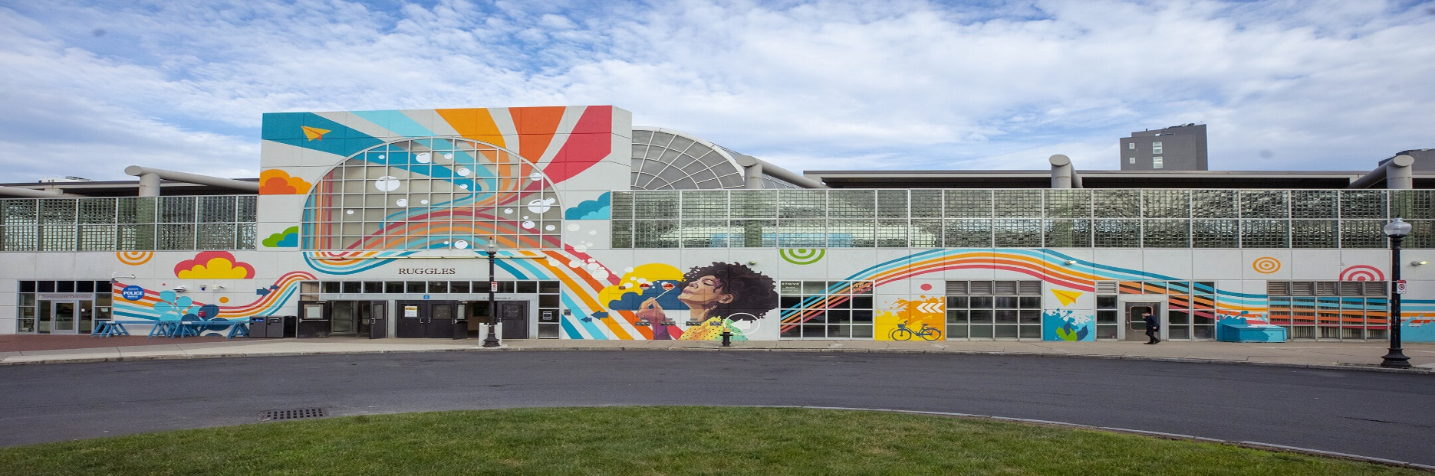

Virtual Public Meeting:
Ruggles Station Improvements Project - Phase II

DATE:

Wednesday, June 1st, 2022
from 6:00 p.m.

to 7:30 p.m.

LOCATION:
Virtual Public Meeting

HOW TO PARTICIPATE:
Visit the Project Webpage

MBTA.com/RugglesImprovements

PROJECT EMAIL:

RugglesImprovements@mbta.com
EVENT DESCRIPTION
This meeting is being held to discuss the Ruggles Station Improvements Project, which consists of providing improved accessibility features, wayfinding, and increased overall system safety.
Please join the Ruggles Station Improvements project team for an online public meeting to learn about station updates.
This meeting will be held online, via Zoom. The project team will begin with a presentation at 6:00 PM, followed by time for Questions & Answers.

HOW TO PARTICIPATE
Instructions on how to join and participate will be posted on the project website under ‘Upcoming Events’ ahead of the meeting: MBTA.com/RugglesImprovements
Building a better T.

ACCOMMODATIONS
These meetings are accessible to people with disabilities and those with limited English proficiency. Accessibility accommodations and language services will be provided free of charge, upon request, as available. Such services include documents in alternate formats, translated materials, assistive listening devices, and interpreters (including American Sign Language).
For accommodation or language assistance, please contact MassDOT’s Chief Diversity and Civil Rights Officer by phone (857-368-8580), fax (857-368-0602), TTD/TTY (857-368-0603) or by email at MASSDOT.CivilRights@dot.state.ma.us.

