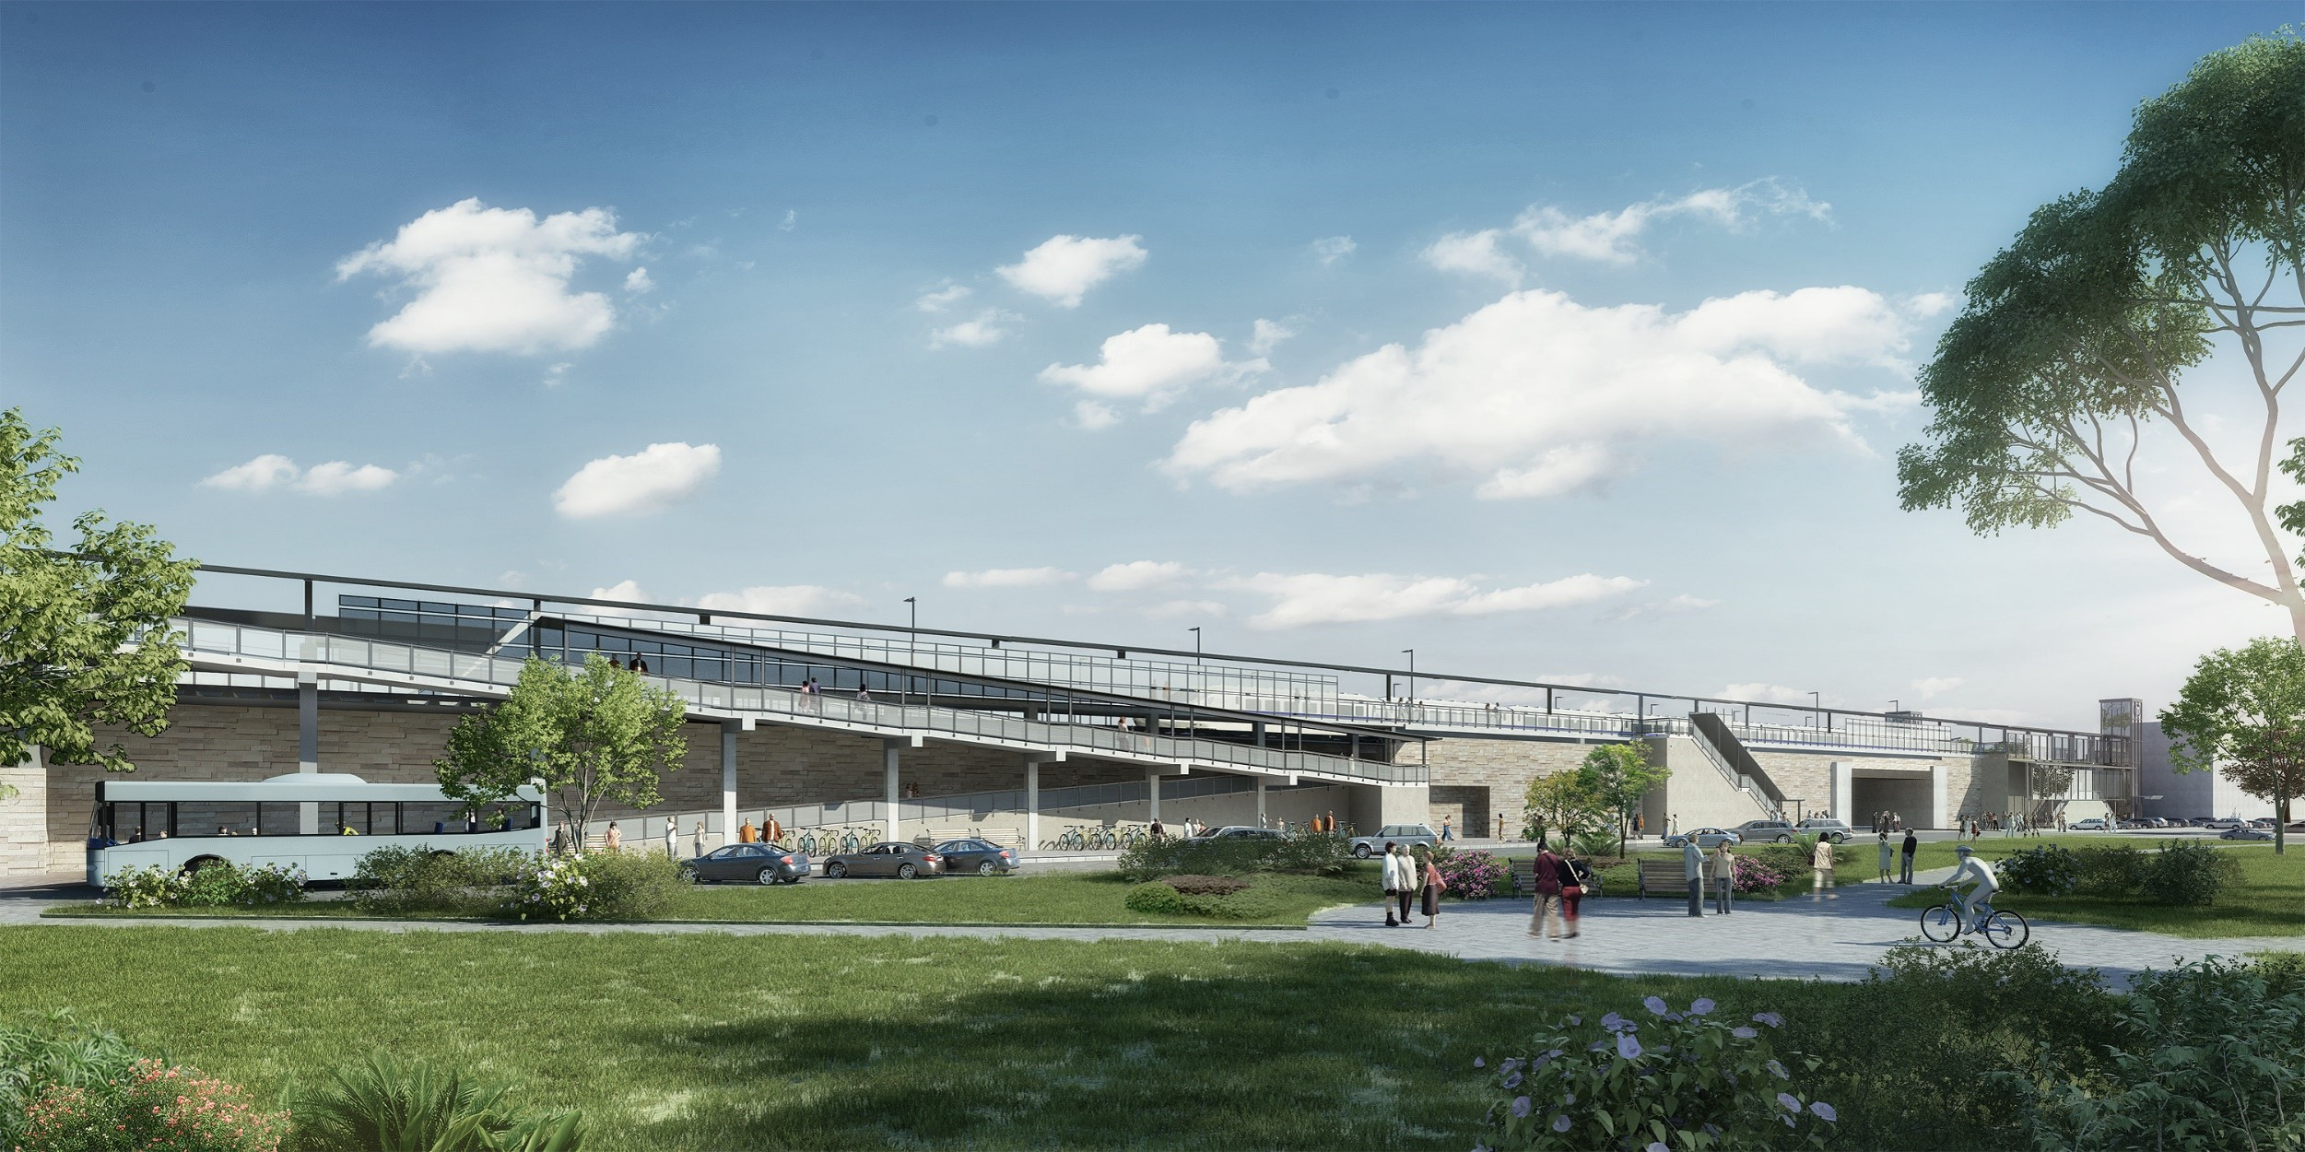MBTA Commuter Rail Winchester Station - Advisory
Winchester Station Design

- In December 2021, the MBTA awarded a construction contract to Barletta Engineering to complete the Winchester Station Accessibility Improvements project.
- The contractor anticipates mobilizing on site on the week of March 28. This includes the contractor performing surveys of the area and preparing the work site with fence installation, placing vibration monitors, pest management etc.
- Beginning April 4th, all parking at Laraway Road and directly adjacent to the station will be removed throughout the duration of construction
- Noticeable construction activity is anticipated to begin in the Summer of 2022. Construction advisories will be distributed ahead of any significant work taking place. Neighbors can expect increased noise and periods of vibration from heavy equipment and machinery during the early phases of work.
- For more information on this project and to sign up for email updates please visit: MBTA.com/WinchesterStation

We appreciate your patience as we work to complete this important accessibility improvement project.

If you have any questions, or would like to sign up for project updates, please feel free to contact the project team at
WinchesterStation@mbta.com

MBTA.com/WinchesterStation

