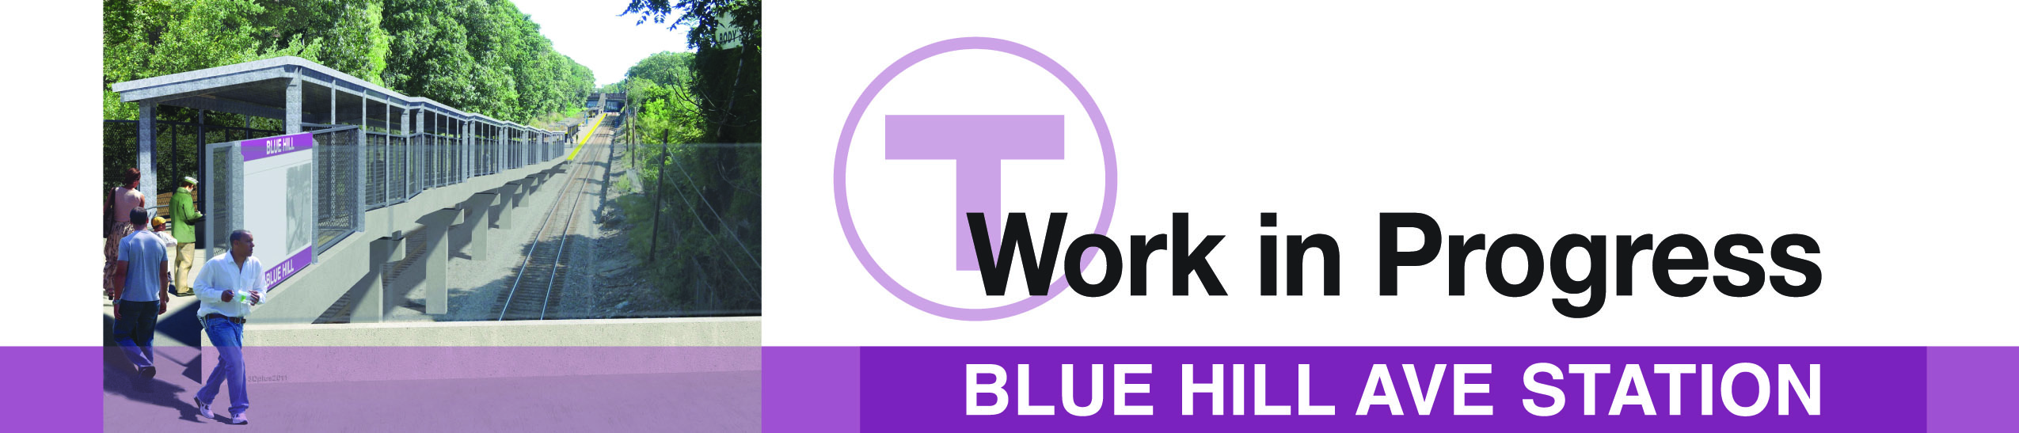

**Job Fair and Informational Meet & Greet**

Blue Hill Ave Station Construction

**Date:** Tuesday, August 8, 2017

**Time:** 6:30PM – 8:30PM

**Location:** Mildred Ave Community Center – Auditorium

5 Mildred Avenue, Mattapan

**General Information:**

McCourt Construction is the contractor for the new Blue Hill Avenue Commuter Rail Station project. The station is being constructed between Blue Hill Avenue and Cummins Highway. This new station will provide a one-seat ride and faster travel time to not only Boston, but the surrounding neighborhood areas on the Fairmount Line.

**Job Fair/Meet & Greet:**

You are invited to an opportunity to meet the contractor and get an update on the construction project. The contractor will also take this opportunity to open their doors by providing job applications to possible new employees.

Locations are accessible to people with disabilities. MassDOT provides reasonable accommodations and/or language assistance free of charge upon request (including but not limited to interpreters in American Sign Language and languages other than English, open or closed captioning for videos, assistive listening devices and alternate material formats, such as audio tapes, Braille and large print), as available. For accommodation or language assistance, please contact Trish Foley by phone (857-368-8907), or by email (trish.foley@dot.state.ma.us). Requests should be made as soon as possible prior to the meeting, and for more difficult to arrange services including sign-language, CART or language translation or interpretation, requests should be made as soon as possible before the meeting. In case of inclement weather, meeting cancellation announcements will be posted on the internet at http://www.mbta.com**.**